## Engineer Deadman

### Scope

The purpose of an Engineer Deadman System is to monitor engine room activity and detect engineer disability which could lead to marine accidents. The system monitors the awareness of the *engineer on duty* and automatically alerts another qualified engineer if for any reason the engineer on duty becomes incapable of performing his duties. This purpose is achieved by a series of indications and alarms to alert first the engineer on duty and, if he does not respond, then to alert another qualified engineer by means of a general alarm.

Additionally, the Engineer Deadman System may provide the engineer on duty with a means of calling for immediate assistance if required. The Engineer Deadman System should be operational whenever the engine room is attended and/or manned, unless inhibited by the Chief Engineer.

### The Engineer Deadman System incorporates the following operational modes:

* Manual ON (In operation when engine room is attended)
* Manual OFF (Does not operate under any circumstances)

*The Deadman timer can only be switched on or off by inserting a password. This to prevent illicit usage of the Deadman timer (see Figure 3‑1). Fill in the password and press enter, or the green checkmark to engage. The red “X” is to return.*

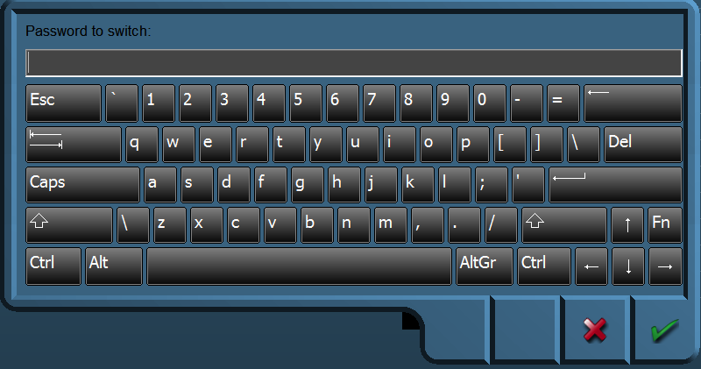

Figure 3‑1: Password entrance panel

### Operational State

Once operational, the alarm system remains dormant for a period of 30 minutes. At the end of this dormant period, the alarm system initiates a visual and audible indication on the AMS.

### Reset function

It is not possible to initiate the reset function or cancel any audible alarm from any device, equipment or system not physically located in areas of the engine room or ECR (local silence is allowed).

The reset function is only available in positions in the engine room and ECR. The reset function is easily accessible from the anywhere in the engine room.

The reset function cancels the visual indication and all audible alarms and initiates a further dormant period. If the reset function is activated before the end of the dormant period, the period should be re-initiated to run for its full duration from the time of the reset.

A continuous activation of any reset device triggers the emergency call facility within 3 seconds.

### Emergency call facility

Means are provided in the engine room to immediately activate the visual and audible alarm by means of an Emergency Call push button or similar. Holding any reset button for at least 3 seconds also triggers the emergency call facility.